PROJECT PROPOSAL

TITLE : SUPPORT TO FMIS – DEVELOPMENT OF
ACCOUNTING INFORMATION SYSTEM
IMPLEMENTING OFFICE : Provincial Accounting Office
PROJECT COST : Php 400,000.00

II. RATIONALE AND BACKGROUND

The financial statements prepared by the Provincial Accounting Office are part of the vital collective information used by the management to come about a sound decision. Reliability and relevance as to its contents are expected to these financial statements.

In the advent of technology, the Provincial Government of Agusan del Sur has created a Management Information Service to cater the need of having a computer-based system. One of the advantages derived from a computer-based system is a faster service delivery and processing of transactions providing service convenience to clients and employees. Moreover, generation of reports has been made fast and easy.

To give support and provide an easier way to financial management, these systems have been already made functional to the Provincial Budget Office and the Provincial Treasury. However, the accounting office is still in manual operation which could not be at phase with the two offices, thus, defeat the purpose of providing timely information in the financial management due to back log and volume of transactions. This condition contributes notably to the recurring issues reported in the audit reports and untimely preparation and submission of financial statements.

To be able to resolve the issues reported in the audit reports and give way to a new era of management decision making derived from well-build financial information through a more reliable and relevant information provided by a computer-based accounting system, this project proposal has been made.

III. GOALS AND OBJECTIVES

- Develop and improve the accounting system
- Provide timely and more accurate financial reports
- Fast and easy generation of reports

IV. PROJECT DESCRIPTION

Government accounting is the language of governance; the policies and procedures of which are embodied in the New Government Accounting System (NGAS); its output provides the financial condition and result of operations of government units.

The proposed project involves essentially the hiring of a programmer and an accountant who will take keen look on the crafting and development of the computer-based accounting system in support to MIS programmers to observe system’s strict adherence to NGAS.

The computer-based accounting information system will be link to the provincial budget office and provincial treasury systems. This would provide an avenue to eliminate the issues of not reconciled account balances of the three departments, caused basically with the gap on operation procedures specifically computer-based system to manual system and policies applied in accounting system such as a modified accrual basis of accounting (Under this method, all expenses shall be recognized when incurred. Income shall be on accrual basis (e.g. Share from Internal Revenue Collections) except for transactions where accrual basis is impractical (e.g. Market Fees) or when other methods may be required by law). The system linkage will give an easy identification of reconciling items.

Holistically, the installation of a computer-based accounting information system adheres to the province’ goal of developing an in-house, fully functional financial management information system (FMIS) and providing service delivery convenience to its constituents. Needless to say, the computerization of accounting system will complete the set of an in-house financial management information system.

V. IMPLEMENTATION METHODOLOGY
- Hiring of an accountant and a programmer to support computer-based accounting system development
- System design and crafting
- System review for implementation
- Approve the system for implementation
- Implementation and adoption of the computer-based accounting information system
- Continuous system improvement

VI. BUDGETARY REQUIREMENTS

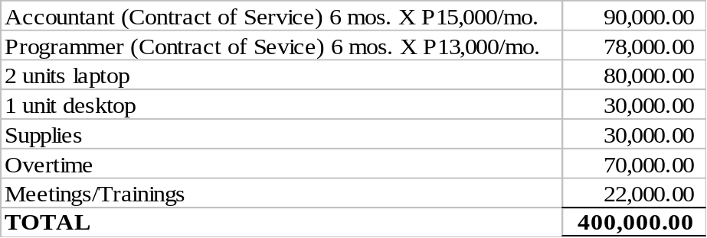

Source of fund – European Commission Variable Tranche

Prepared by:

JAVE NHORIEL N. BORDAJE, CPA
Accountant

Recommending Approval:

JOY D. LAGAT, CPA JOEL L. ESPARAGOZA, MD, MHA
OIC - Provincial Accountant Provincial Health Officer II

Approved:

MARIA VALENTINA G. PLAZA
Provincial Governor

